Made by:

Rain Sensor

( Sec 1 )

( Sec 1 )

( Sec 1 )

( Sec 1 )

-1أﺣﻤﺪ ﻟﻄﻔﻲ اﻟﺴﯿﺪ ﻏﺮﺑﺎوي -2أﺣﻤﺪ أﺣﻤﺪ ﻋﺒﺪاﻟﺴﻼم أﺣﻤﺪ -3اﺣﻤﺪ ﺳﻤﯿﺮ ھﻤﺎم ﺗﻤﺎم -4اﺣﻤﺪ طﺎرق ﻣﺤﻤﻮد ﺣﺴﺎﻧﯿﻦ

اﻟﻔﺮﻗﺔ : اﻟﺜﺎﻧﯿﺔ اﺗﺼﺎﻻت ﻣﺎدة : اﻟﻘﯿﺎﺳﺎت ﻛﻠﯿﺔ : ھﻨﺪﺳﺔ ﺣﻠﻮان دﻛﺘﻮرة : ﺳﻠﻮى اﻟﺼﺒﺎن

Rain Alarm Project is a simple but very useful project that detects Rain (Rain

.Water) and automatically triggers an alarm or buzzer

Water is a basic need in every one’s life. Saving water and proper usage of water is very important. Here is an easy project which will give the alarm when there is rain, so that we can make some actions for rain

.water harvesting and also save the rain water for using it later

With the help of saving this rain water through rain water harvesting, we can increase the levels of underground water by using underwater

.recharge technique

Rain water detector will detect the rain and make an alert; rain water detector is used in the irrigation field, home automation, communication, automobiles etc. Here is the simple and reliable circuit of rain water detector which can be constructed at low cost

**Circuit Diagram**

.The circuit diagram from the Rain Alarm Project is shown in the below image

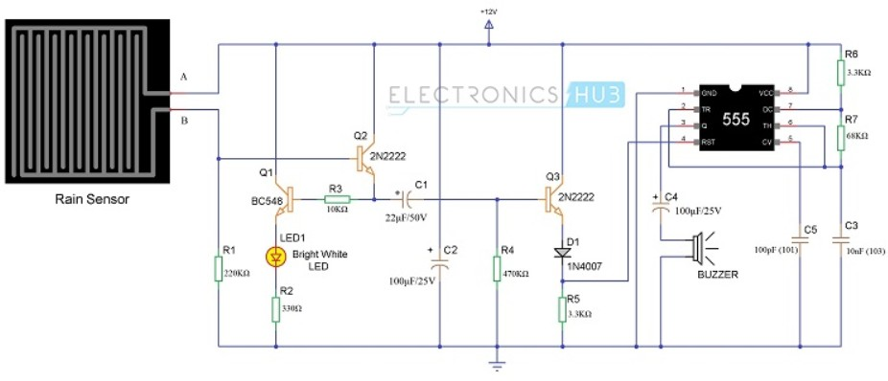

# Components Required

* **1 x Small Rain Sensor**
* **1 x 555 Timer IC**
* **1 x BC548 NPN Transistor**
* **2 x 2N2222 NPN Transistor**
* **1 x Bright White LED**
* **1x 1N4007 PN Junction Diode**
* **1 x 220 KΩ Resistor (1/4 Watt)**
* **1 x 330 Ω Resistor (1/4 Watt)**
* **1 x 10 KΩ Resistor (1/4 Watt)**
* **1 x 470 KΩ Resistor (1/4 Watt)**
* **2 x 3.3 KΩ Resistor (1/4 Watt)**
* **1 x 68 KΩ Resistor (1/4 Watt)**
* **1 x 22 µF Capacitor (Polarized)**
* **2 x 100 µF Capacitor (Polarized)**
* **1 x 10nF Ceramic Capacitor (Code – 103)**
* **1 x 100pF Ceramic Capacitor (Code – 101)**
* **1 x Buzzer (or Speaker – 8Ω)**
* **Connecting Wires**
* **Breadboard**
* **9 V Power Supply**

# Rain Water Sensor

The Rain Water Sensor used in this project is shown in the image below. It is a simple sensor and it is an easy-to-use tool for detecting rain. It can act as a simple switch, where the switch is normally open and when there is rain, the switch closes.

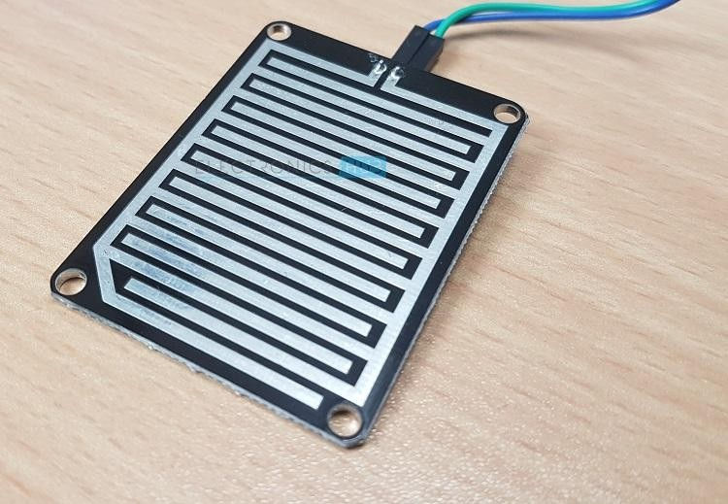

**Circuit simulation diagram using Proteus**

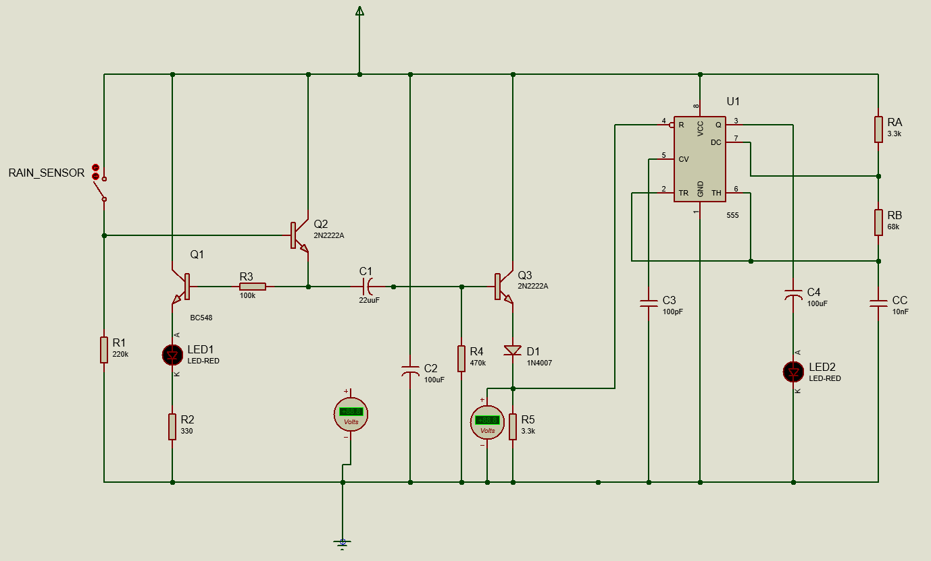

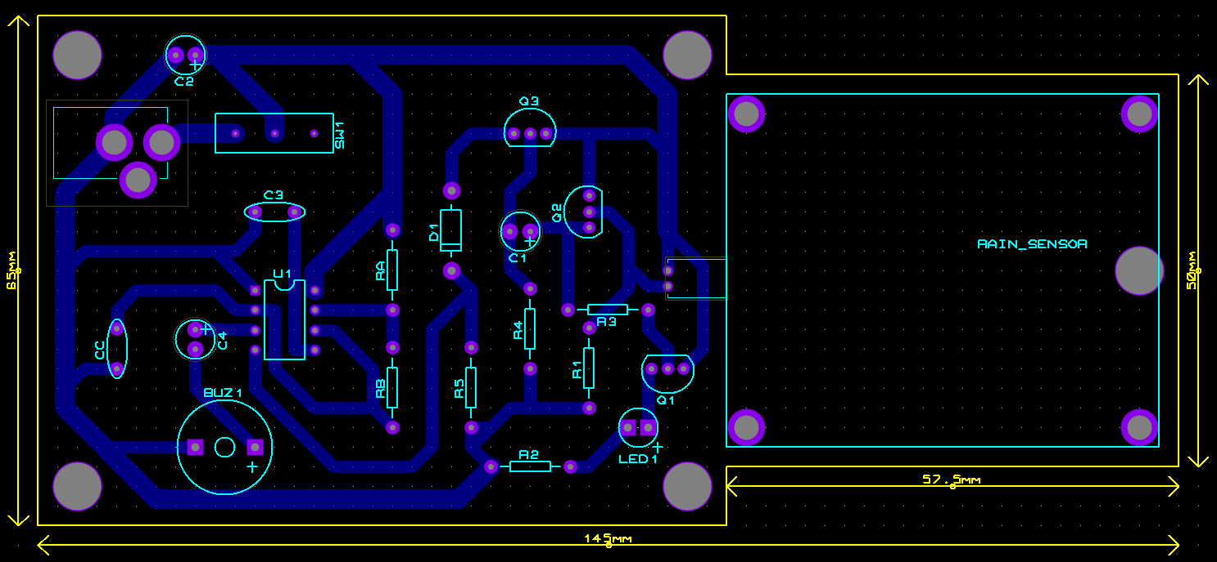

**Image of the circuit on the Breadboard**

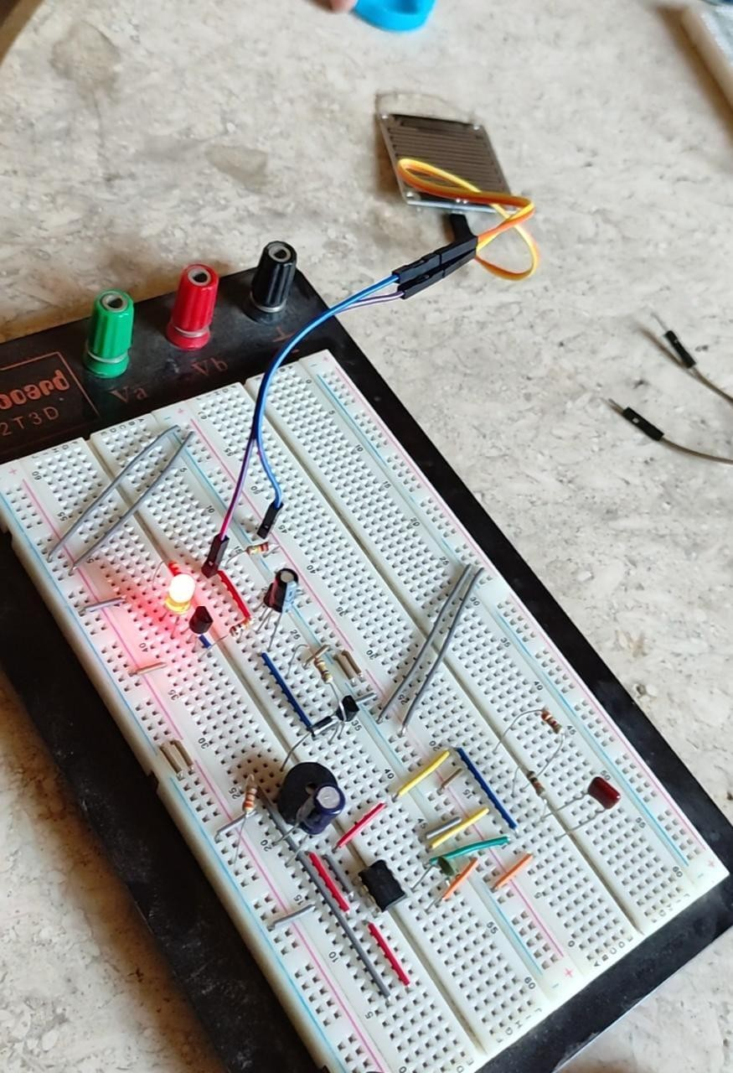

**Image of the circuit on the PCP**

# Rain Alarm Project Circuit Applications:

1. **In the irrigation, it will detect the rain and immediately alert the farmer.**
2. **In automobiles, when the rain detector detects the rain it will immediately activate the wipers and inform the driver.**
3. **In communications, it will boost the power of the antenna and increase the signal strength to send or receive the signals.**
4. **In a normal household, with the help of a rainwater detector, we can automatically save the rainwater. (This can be done only when home automation is done and there is proper equipment to save the rainwater. In this, the rainwater detector will detect the rain and helps to switch ON the equipment which will automatically save rainwater for different purposes).**
5. **This can also be used if there is chemical rain also. This is very common in industrial areas.**

.